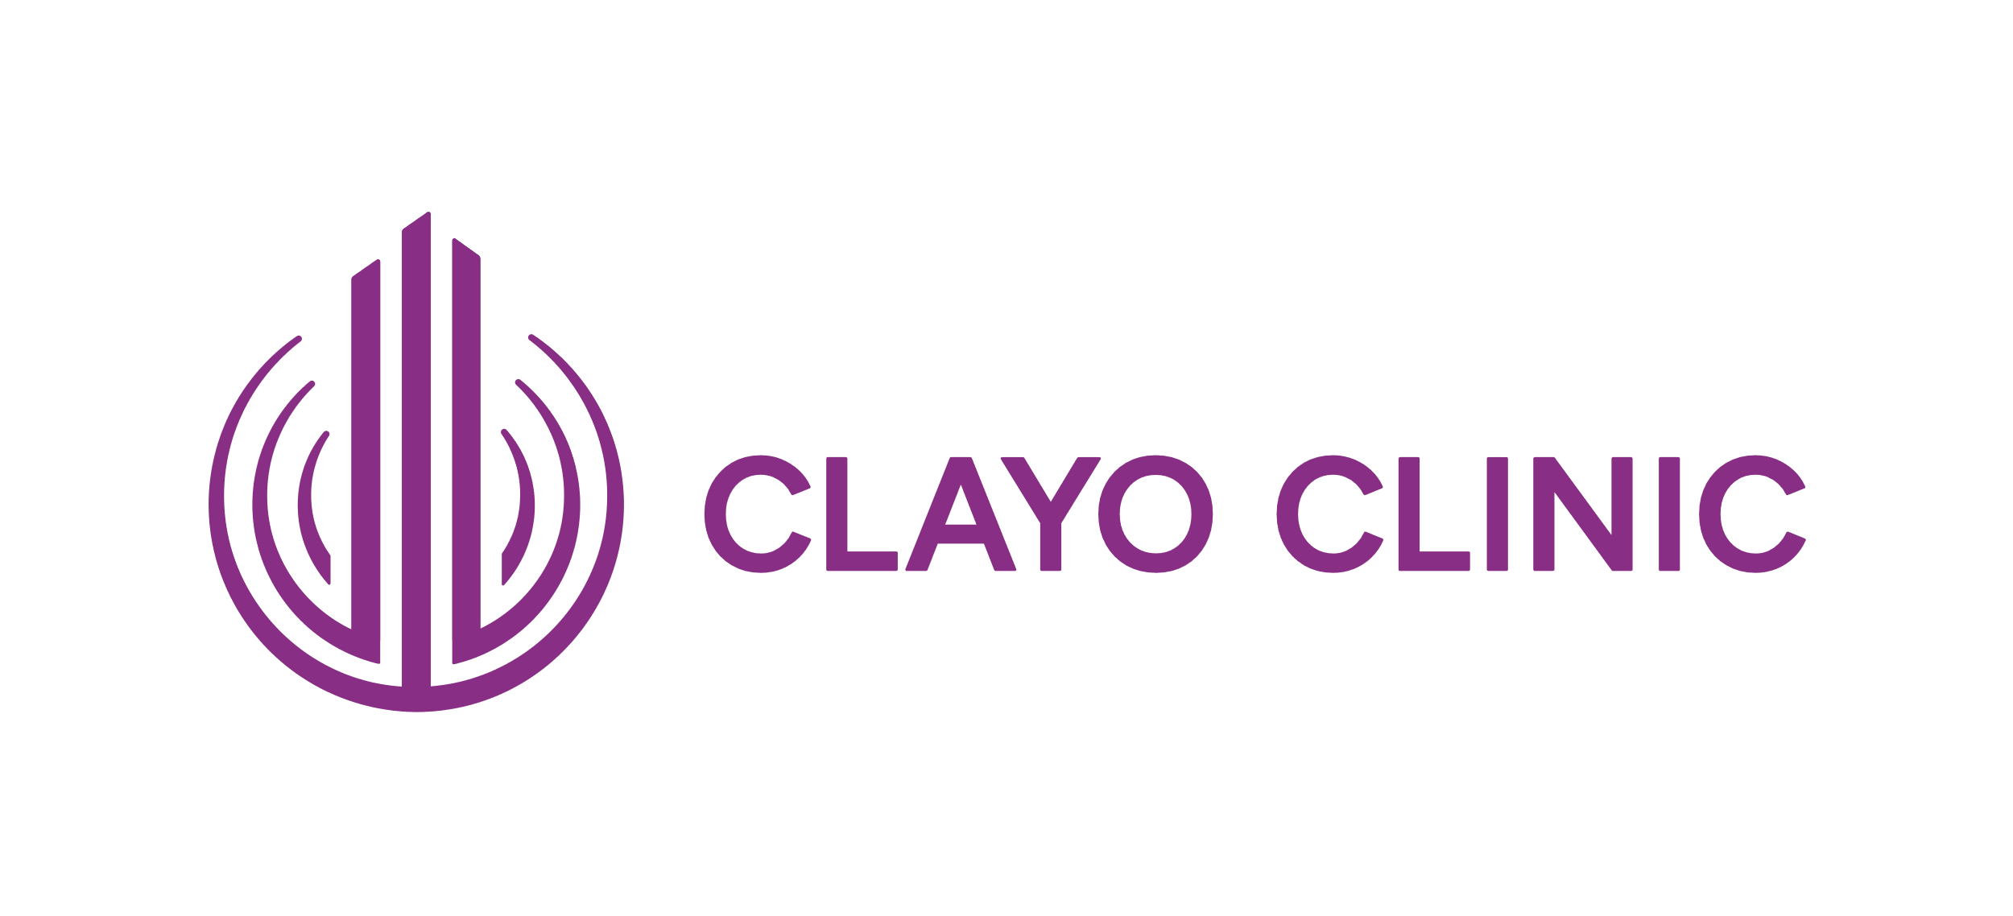
Statement on the Processing of Personal Data

Clayo Clinic s.r.o. having registered office at Nádražní 762/32, Smíchov, 150 00 Prague 5, Company ID No.: 177 95 354 (hereinafter as the “Company”) has issued this Statement on the Processing of Personal Data and Information Notice (hereinafter as the “Statement”), in accordance with Regulation (EU) 2016/679 of the European Parliament and of the Council on the protection of natural persons with regard to the processing of personal data (General Data Protection Regulation) (hereinafter as the “GDPR”), which took effect on 25.05.2018, and Adaptation Act No. 110/2019 Coll., on the Processing of Personal Data.
For the Czech version of the GDPR go to the following website: https://eurlex.europa.eu/legal-content/CS/TXT/?uri=CELEX:32016R0679
Information for the Company’s employees and other workers related to the GDPR is provided in a separate information notice issued by the Company for its employees.
This Statement is issued by the Company primarily for the purpose of informing its clients (patients) and contractual partners (including in particular providers of healthcare services) who are understood as data subjects, and whose data is processed by the Company as a controller in the framework of its activities.

I. Introduction
Since the Company highly values the trust that our clients and contractual partners have in us, we perceive the protection of their privacy and personal data as very important. For this reason, the Company has issued this Statement for our clients and contractual partners to obtain additional information on the handling of personal data and the rights they have in this connection.

II. What information will you find in this document?
- Explanation of key terms (Article III)
- Method of processing personal data (Article IV)
- Categories of personal data, purposes and the legal basis for processing (Article V)
- Processing of personal data on the basis of consent (Article VI)
- Contact data of the Company as a data controller (Article VII)
- Contact data of the Data Protection Officer (Article VIII)
- Categories of personal data recipients (Article IX)
- Retention period of personal data (Article X)
- Rights of data subjects in relation to the protection of their personal data (Article XI)
- Consequences of failure to provide personal data (Article XII)

III. Explanation of key terms
First and foremost, we wish to explain the key terms used in this Statement. The terms have been taken from the GDPR, where their precise legal definitions are formulated.
For the purposes of this Statement and for the sake of clarity, we have taken the liberty to simplify and clarify some of the legal definitions:
- “personal data” = all data about the data subject
- “data subject” = a unique natural person (a human being) who can be identified, directly or indirectly, on the basis of certain data
- “processing” = any operation concerning personal data, especially its collection, recording, organization, structuring, storing, adaptation or modification, search, viewing, use, disclosure by transmission, distribution or any other form of disclosure, alignment or combination, restriction, erasure or destruction
- “personal data controller” = a natural or legal person or public authority who/which determines purposes and tools for personal data processing
- “personal data processor” = a natural or legal person or public authority who/which processes personal data for the controller

IV. Method of processing personal data
Personal data is processed primarily on the Company’s premises by its duly trained workers, or, as applicable, data is processed in specified cases by third-party processors contracted by the Company for this purpose. Data is processed by computer technology, or manually in the case of personal data in paper form, in accordance with security principles adopted for ensuring that personal data is handled properly, including data and security integrity of the relevant systems.
To this end, the Company has adopted technical and organizational measures to ensure the protection of personal data, especially measures preventing unauthorized or accidental access to, alteration, destruction or loss of personal data, unauthorized transfers, unauthorized processing and other misuse of personal data.
Pursuant to the GDPR, the Company may transfer personal data to other countries of the European Union, in particular as regards the use of information systems where operators of the relevant cloud services have server storage facilities in other countries of the European Union.
All entities that might be provided personal data respect the right of data subjects to privacy and are duty-bound to proceed as per applicable legal relations concerning personal data protection.

V. Categories of personal data, purposes and the legal basis for processing
The Company processes personal data mainly for the purpose of providing healthcare services and for related activities (including in particular the maintenance of medical records), primarily for the purpose of fulfilling its legal obligations. Basically, the following categories of personal data are concerned:
- Identification data – first name, surname, birth reg. no./insured person no., date and place of birth, residence address/registered office address, health insurance company, insured person number, signature
- Contact data – contact address, telephone number, email address and other similar information
- Health data (a special category of personal data) - medical history, diagnosis, results of laboratory examinations, medical records, genetic data and similar sensitive information related to health of the Company’s patients

The Company also processes personal data for the purpose of fulfilling rights and obligations arising from contracts with the Company or in this connection, entered into between the Company and its contractual partners (mainly providers of healthcare services, patients - self-payers, customers and suppliers), based on and within the bounds of such contracts; the following categories of personal data are concerned:
- Identification data – first name, surname, birth reg. no., date of birth, residence address/registered office address, health insurance company, insured person number, Company ID, Tax ID, identification number of facility/department, signature
- Contact data – contact address, telephone number, email address, fax, and other similar information
- Details of education/qualification – professional competences, continuing education and certificates of qualification attained, improving of qualification, and other similar information
- Payment data – bank account number, payment history

The processing of personal data as delineated above is necessary for the Company to fulfil its legal obligations as a provider of healthcare services and to perform the contracts entered into. In the above cases, the Company therefore in principle does not need the consent of the given data subject to the processing of personal data.
The Company also processes certain personal data of its clients and contractual partners, or, as the case may be, third persons, where necessary to protect the Company’s property and other legitimate interests.
However, in all these cases, the Company takes strict care to ensure that such interests are not overridden by the interests or fundamental rights and freedoms of data subjects whose data is to be processed.
To protect its property, the Company operates a CCTV system in some of its premises. The operation of a CCTV system is subject to strictly determined rules and is done only as necessary so as not to interfere with the privacy of individuals in an excessive manner.
This processing is necessary for the purpose of the Company’s legitimate interests, and, accordingly, the Company does not need the consent of data subjects to process that personal data.

VI. Processing of personal data on the basis of consent
There is a narrow category of personal data that is processed by the Company on the basis of consent of data subjects.
In order to process any data that fall under none of the above categories, we need your consent in principle. In this narrow category of personal data, we process e.g. data about the Company’s website traffic (especially via cookies, or IP address of the website visitor and similar data).
You are not obliged to provide us with the above data, and it is processed only on the basis of your consent.
You can withdraw your consent to the processing of the aforesaid data at any times by writing to the email address gdpr@clayoclinic.cz.
Nevertheless, the withdrawal of your consent will not affect the lawfulness of the processing of personal data prior to its withdrawal.

VII. Contact data of the Company as a data controller
Trade name: Clayo Clinic s.r.o.
Company ID: 177 95 354
Having registered office at Nádražní 762/32, Smíchov, 150 00 Prague 5
Registered in the Commercial Register maintained by the Municipal Court in Prague, Section C, Insert 376848

VIII. Contact data of the Data Protection Officer
You can contact the Company through the mediation of the Data Protection Officer in any matters related to personal data, electronically at the following email address gdpr@clayoclinic.cz or by writing to the address Nádražní 762/32, Smíchov, 150 00 Prague 5.

IX. Categories of personal data recipients
Even though the Company’s objective is to process any received personal data using its own capacities, in some cases, personal data need to be transferred to other entities (“personal data recipients”). In order to protect personal data, the Company has set up internal processes in a way ensuring that such personal data is transferred to specified third persons, only in justified cases and to a necessary extent.
For the Company to fulfil its obligations imposed by legal regulations or the contracts entered into, the Company transfers data about its clients (patients) and contractual partners to fulfil its legal obligations to certain their parties, which, inter alia, include health insurance companies, other providers of healthcare services, tax administrators as well as processors authorized by the Company to process personal data for the purpose of the performance of the Company’s legal and/or contractual obligations (data archiving operators, auditors, external lawyers, operators of the Company’s IT system operators, entities performing billing for health services provided etc.).

X. Retention period of personal data
The Company has set up internal rules such that your data are retained only for a necessary period. Any data that must be processed by the Company for the performance of its legal requirements are therefore retained for a period as imposed on the Company by applicable legal regulations.
The period of data processing and retention at the Company is determined mainly by statutory periods according to Regulation No. 98/2012 Coll., on Medical Documentation, as amended, Act No. 582/1991 Coll., on the Organisation and Implementation of Social Security, as amended, Transplantation Act No. 97/2019 Coll. (which lays down a 10-year period) and Act No. 563/1991 Coll., on Accounting, as amended (e.g. for medical documentation, the time-limit is up to 100 years in certain cases).
The personal data processed on the basis of your consent is processed exclusively for the duration of that consent.
The recordings made by the Company's camera system are continuously deleted from the relevant data storage within 5 working days of their acquisition (the data is replaced by the currently acquired recording). A longer archiving period for CCTV footage is only permissible if the footage shows that there has been an unlawful interference with the Company's property or other rights and protected interests.

XI. Rights of data subjects in relation to the protection of their personal data
In particular, you have the following rights in relation to the processing of your personal data by the Company under the terms set forth in the GDPR:
- Right to access personal data concerning you - you have a right to obtain from the Company a confirmation whether or not your personal data is processed. If your personal data is indeed processed, you have a right to access your personal data (and to obtain a copy of the personal data free of charge and to obtain information related to the processing of the personal data.
- Right to rectification or completion of personal data in the case of inaccurate or incomplete personal data.
- Right to erase of personal data concerning you (the right “to be forgotten”), where the Company will destroy your personal data and will no longer process it, provided that (a) the personal data is no longer necessary for the purposes for which it was collected or otherwise processed, (b) you withdraw your consent and there is no further legal basis for the processing, (c) you object to the processing and there are no overriding legitimate grounds for the processing, (d) the personal data was processed in contrary to the law, (e) the personal data must be erased for the Company to fulfil its legal obligations, or (f) the personal data was collected in connection with an offer of services of an information society to a child, unless the GDPR allows further processing.
- Right to restrict the processing of personal data related to you if (a) you challenge the accuracy of personal data; (b) you believe the processing of personal data is unlawful and request the restriction of the processing, (c) the Company no longer needs your personal data for the purposes of processes, but you require the personal data for the establishment, exercise or defence of legal claims, (d) you have objected to the processing and the objection has not yet been settled.
- Right to object to the processing of personal data concerning you where the processing of personal data by the Company is done for the performance of a task carried out in the public interest or in the exercise of official authority (needless to say, the Company, in principle, never conducts such processing), based on legitimate interests or direct marketing purposes. Unless the Company demonstrates compelling legitimate grounds for processing that override your interests or rights and freedoms, or for the establishment, exercise or defence of legal claims, the personal data will no longer be processed. In the case you file an objection to the processing data for direct marketing purposes (including profiling), the Company will refrain from processing your personal data for such purposes, regardless of whether there are compelling legitimate grounds for processing.
- The right to lodge a complaint with a supervisory authority, i.e. the Office for Personal Data Protection (seated at Pplk. Sochora 27, 170 00 Prague 7), if you believe that the GDPR or other legal regulations have been violated by the processing of personal data.
- The right to data portability, if automated processing of personal data is carried out on the basis of your consent or in connection with the negotiation or performance on a contract, and this right entitles you to obtain your personal data in a structured, commonly used and machine-readable format. You also have the right to transmit your data to another controller or to ask the Company, where technically feasible, to transfer the same to another controller directly. However, if the exercise of this right might adversely affect rights and freedoms of other persons, the Company will be unable to comply with the request to transfer the data.

XII. Consequences of failure to provide personal data
The provision of personal data of the Company’s clients or contractual partners needed by the Company for maintaining medical records in the scope determined by applicable legal regulations and for the performance of statutory obligations pertaining to the Company as a provider of healthcare services constitutes a lawful requirement and it is also essential for the Company to perform the relevant contract. Without the provision of such personal data, the Company would be unable to fulfil its statutory and contractual obligations; accordingly, failure to provide personal data may result in the Company being unable to conclude the relevant contract or to provide its services.
In the case of personal data processed on the basis of your consent, the provision of such consent is entirely voluntary. Failure to provide consent or withdrawal of the same will have no consequences for you in such case. However, even if your consent is withdrawn, the processing of personal data prior the withdrawal of consent will remain law compliant.

In the case of a repeated request for a copy, the Company has a right to charge a reasonable fee to cover any costs incurred.

